

Chapter 2

CHAPTER 2 Contents:

Chapter 2 17
2.1. Artificial Psychology 18
2.2. Why Artificial Psychology? 19
2.3. Artificial Psychology in Practice 30
2.4. Interpretability and Explainability in a Knowledge-based Approach 34
2.5. Achilles’ heel in Psychology 36

Abstract: Various key concepts are introduced here including artificial intelligence and explainable artificial intelligence and their implementation in artificial psychology in model building. We recommend the use of a training set to estimate models and a separate set of data to test, in an unbiased manner, the predictive validity of the model obtained from the training set. This leads us to the increasingly popular techniques of machine learning and deep learning where the model updates and learns from the data and is able to explore relationships which were not explicitly fed into the model so relies less on pre-programmed apriori assumptions. These differ from classical statistical inference where only pre-defined relationships are included in the model. We allude to deductionism and inductivism and look at assumptions underlying these approaches including multicollinearity. A good model should be parsimionious, be easy to interpret, explainable and understandable. We refer to three stages in the fitting of a model: the pre-model stage, the intrinsic stage and the post-model interpretability stage and to different types of machine learning models.
Keywords: Artificial psychology; Machine learning; Explainability; Interpretability; Artificial intelligence

2.1. Artificial Psychology
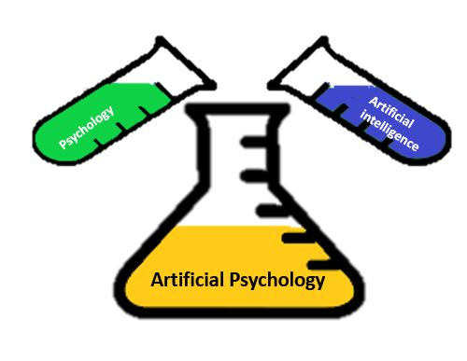
Artificial psychology was first proposed by Dan Curtis in 1963 as a theoretical discipline. Artificial psychology is a combination of psychology and artificial intelligence. As a comprehensive definition, psychology can be called the science of studying an individual’s mental processes and behaviors (Crowder, et al., 2012)
Artificial intelligence also has a wide variety of definitions, and it may not be possible to provide a comprehensive definition that encompasses all of its dimensions; however, it is a science that deals with the design of intelligent machines and systems; systems that can perform tasks requiring human intelligence (Crowder & Friess, 2010).
Here, we return to artificial psychology. The developments in psychology and artificial intelligence as of 2022, have addressed the needs of researchers. Here, artificial psychology has a theoretical framework or is simply a theory on which the artificial psychology presented in this book relies to look at the world of psychology In other words, artificial psychology uses artificial intelligence to design, train, test, and ultimately deploy methodological models in the psychological context. This representation of artificial psychology is shown in Figure 2.1.

Psychology
Artificial Intelligence
Data Gathering
Training and testing the models
Interpretability and Explainability
Human

Figure2.1 Representation of artificial psychology
This theoretical framework has features borrowed from psychology, artificial intelligence, and the psychological contexts in question. As the basis of artificial psychology, this theory is interpretable and explainable in artificial intelligence-based psychology.

Artificial psychology in this book relies on the above theory for prediction and classification to provide robust, interpretable, and explainable models. Here, artificial psychology refers to the scientific application of this theory.

2.2. Why Artificial Psychology?

The question we have to address here is why artificial psychology is significant, as its application is becoming increasingly prevalent.
From the data analysis perspective, psychology mainly aimed to create models to infer human behavior for about a century. Researchers in behavioral sciences used the null hypothesis test to conclude and find the causality and underlying mechanisms of human behaviors (...).
For nearly two decades, machine learning has received increasing attention in scholarly studies as a branch of artificial intelligence (Lipkova et al., 2022). Machine learning is part of artificial intelligence and perhaps the most essential and practical part of artificial intelligence in artificial psychology. There are numerous definitions of machine learning, but the definition given by Samuel in 1959 is taken as the working definition (Buchanan et al., 2005).
Machine learning is a branch of study that enables computers to learn without being explicitly programmed. Perhaps the most prominent part of this definition is “without being explicitly programmed.” In the case of obvious programming, the software receives the input data and generates the output according to the specific rules defined by the programmer (Figure 2.2).

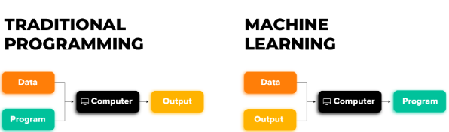
Figure 2.2 Comparison of Conventional programing and Machine learning
We know that these rules guarantee the explainability and transparency of the system as it is possible to understand exactly what those rules (algorithms) follow. Thus, knowledge of the algorithm answers “why,” “what,” and “how” in the model, and thus explainability is achieved. We will return to the topic of explainability later. The age of algorithms has given way to the age of data. Figure 3.2 indicated the short history of machine learning. Machine learning seeks to design models to predict unseen data with high accuracy. Fans of inferential statistics should not despair. Inferential statistics can still be used to test null hypotheses. These methods are used in inferential statistics to infer human behaviors. Behavioral inference means that the cause of behaviors and relationships between variables are explained, and the best possible insight into human behavior is obtained. These methods have limiting assumptions. The most significant limitation is that the generalizability of models is questionable.
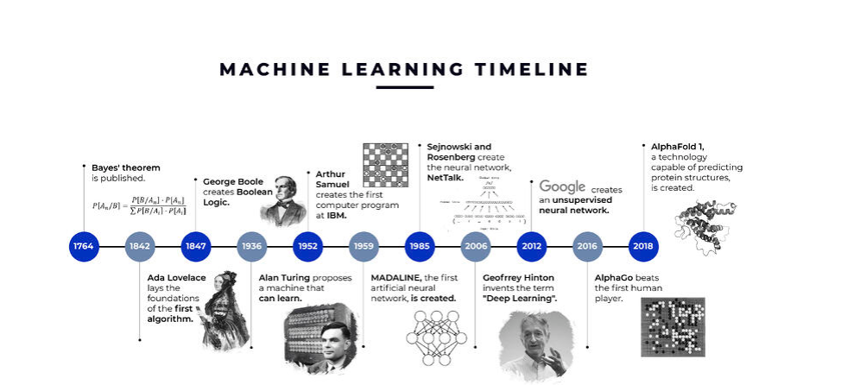
Figure 3.2 indicated the short history of machine learning from https://www.algotive.ai/blog/machine-learning-what-is-ml-and-how-does-it-work

In behavioral sciences and psychology, statistical inference is mainly based on statistical tests on aggregated data. The underlying assumption of these statistical tests is that what is estimated from the groups can be generalized to individuals. The generalization of group-based findings to single-case levels is interpretable as long as the studied process is ergodic. Ergodicity indicates that the studied effects are homogeneous among individuals and constant over time (Oliveira, &Werlan,2007). Psychological constructs are organized over time in individuals, and in the case of individual exceptions, the group-based generalizability is not ergodic.
On the other hand, inferential models are utilized for samples and variables that are small to medium in size. Lack of multicollinearity is another assumption. Yarkoni and Westfall (2017) believe that one reason for choosing classical inferential statistical methods in psychology is the poor understanding of the tools that make successful predictions and the slow deployment rate of these tools after creation. Data and AI (Artificial Intelligence) scientists are able to target the limitations of classical inferential statistics, such as a large number of assumptions, generalizability, complexity, low number of input variables and poor predictive power.
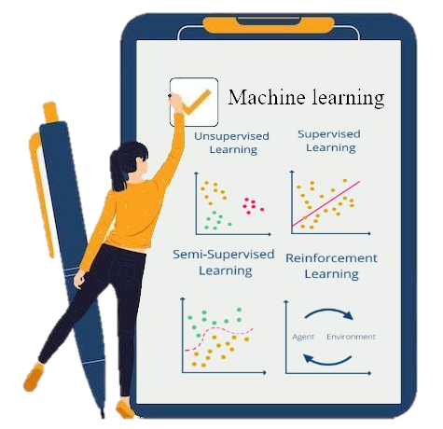
Developments in recent years have targeted mainly the limitations of classical statistics. The models used for prediction create systems that incorporate advanced statistical and probabilistic methods. These methods learn from data to detect and extract hidden patterns in order to predict unseen or out-of-sample data. These AI-based predictive models are called machine learning (ML). Machine learning has significant advantages over the models used for statistical inference. Machine learning is a relief from the cumbersome assumptions of inferential statistics. These assumptions work well on paper, but in real life, they are not generally met regarding the data. Machine learning is based on minimal a priori assumptions. In ML, there is no need to select variables because, in classical inferential statistics, multicollinearity is an erosive problem.
Machine learning can be utilized for high-dimensional data, where the number of rows is less than the number of columns in the dataset file. Highly correlated variables and small sample sizes are common problems in cognitive and clinical psychology and neuroscience. For example, consider predicting the disorder based on EEG-based brain features in people with clinical depression. Large samples and extraction of brain features are time-consuming, costly processes.
Machine learning provides good predictions even if the input variables are beyond individuals. It means the models which are based on Machine learning can perform well with new data (unseen data) (Xin et al,2018).
One of the problems of research and theoretical models in psychological sciences is their complexity. This complexity raises serious issues in modeling. Complex models involve the selection and use of many variables. Psychological phenomena and mental disorders are mainly complex because of their including subsystems (models) such as emotion, cognition, memory, behavior, and biology (Borsboom et al, 2021). ML enables the building and testing of such models.
ML gives predictive models the ability to model individuals instead of groups. The advanced part of ML, called deep learning, allows one to study complex models and systems. The following is a brief description of machine learning types.
ML makes it possible to make predictions in the case of multiple variables, small samples, and complex or even unknown nonlinear relationships between variables to find hidden patterns. These unique features raise a new problem: that such complexities in the ML pose a severe challenge to interpretability, requiring expertise in interpreting these models.
Statistical and quantitative accuracy precludes qualitative and in-depth interpretation, so even if the accuracy of prediction models performed in the ML is higher than classical inferential statistics, the results might still be questionable. For instance, if we intend to identify depressed people in image-based deep neural networks, and in those images, the depressed people are wearing winter clothes and non-depressed people wearing summer clothes, then the accuracy of prediction in their category is 100. Nevertheless, winter clothes are not related to depression. This shows that high accuracy is not necessarily a good result. The adage of “well-shaped apples are not necessarily tastier” applies here! In recent years, to overcome the problem of uninterpretability in ML, a new field has been developed in artificial intelligence and ML, which is called Explainable Artificial intelligence or ML (XAI) or (XML). The ultimate goal of XAI is to provide models to increase interpretability, transparency, and fairness.
The interpretable model is trained by minimizing cost functions such as weighted root mean square (RMSE). It should be noted that to achieve an interpretable model in ML; the cost function should be minimized to the extent that the complexity and fidelity indices allow. Fidelity can be considered the extent to which an interpretable model can approximate the original model. Let us take a closer look at these features.
The purpose of Explainable Artificial Intelligence (XAI) and consequently Explainable ML (XML), on which, as mentioned, the artificial psychology discussed in this book is based, has different features with the aim of attempting to address the inherent nature of the ML, which is a black box, to gain a better understanding of the decision-making process.
Adadi and Berrada (2018) state that explainable systems are also interpretable if humans understand their operations. This definition indicates that interpretability is closely related to the concept of Explainability, although Gilpin et al. (2018) consider interpretability and fidelity as essential components for the Explainability of models.
They believe a good explanation should be understandable to humans (interpretability) and accurately describe the model behavior in the entire feature space. Interpretability may contain features such as transparency and parsimony. Transparency shows that the explanation is not ambiguous, while parsimony means that the explanation is presented in a simple, concise pattern (Rudin,2019, Zhou, &Chen,2018). Fidelity has features of completeness and soundness (Zhou et al,2021). Completeness indicates that the given explanation describes the overall dynamics of the ML model, while soundness indicates how correct and reliable the explanation is (Figure 4.2). This model is based on Markus et al. (2020).

Explainibility
Interpretability
Fidelity
Clarity
Broadness
Parsimony
Soundness
Completeness

Figure 4.2 Definition of ML Explainiability and related features

Velez and Kim (2017) defined the machine learning environment interpretability as “the ability to explain or present in human terms.” This definition may seem slightly vague. Let us clarify it in the form of an example.
Supposing that as the anxiety increases, the individual performance in the maths test first improves, then is stable, and finally decreases. See Figure 2.7.

Maximum performance
Test anxiety
Performance in math test
Average anxiety
- - - - - - - - - -
- - - - - - - - - - - - - - - -

Figure 4.2 nonlinear relationship between test anxiety and math test performance
Figure 4.2 shows the nonlinear relationship between test anxiety and maths test performance. This relationship is an Inverted-U function.
In this example, interpretability can be understood as how the machine learning system predicts test performance by increasing stress scores. The explainability of this model refers to the fact that it is based on a theory such as Yerkes-Dodson’s law. This general understanding is associated with knowledge discovery (Figure 5.2). Simply put, explainability can be considered the possibility of understanding the mechanics of an ML model.
Low
Arousal
High
Optimal level
Efficiency of memory
Point of waking

Figure 5.2 Relationship between arousal and memory performance
Figure 5.2 shows that Yerkes-Dodson’s law demonstrates an inverted relationship between arousal and memory performance.
Gianfagna and Di Cecco (2021) reveal that regarding the explainability of the machine learning model in practice, we are looking for how much the output will change if different values ​​are placed in a feature that was not in the data.
Explainability requires checking whether the machine learning model is trained on a biased dataset. This feature is fairness which is related to model validation. In addition, research models must be debugged to generate and discover knowledge. Model debugging ensures reliability and robustness. This debugging refers to displaying what is happening behind the scenes by examining the model. A small change in input data should not lead to a considerable change in output. This examination contributes to the stability and robustness of the model.
It should be borne in mind that the most complex function of the ML models is to acquire and increase a clear understanding of psychological processes, events, and systems studied in the psychological sciences. As previously discussed, the discovery of psychological knowledge is the primary purpose of explainable artificial psychology and cannot be interpreted by merely predicting and accurately classifying the application of these models in the psychological sciences. Extraction of scientific knowledge is not entirely done by prediction. Artificial psychology is required to create the results with explainability and interpretability. Furthermore, another point that emerged in the data age is that the solid line between correlation and causality is fading. Correlation deals with the relationship of two or more variables that change together, i.e., they have a common variance, but this correlation does not indicate causality. In causality, one variable causes another (cause and effect).
In a town, as the number of storks increased, the number of infants also increased. This random association should not be considered a correlation because an illusory correlation causes it, and by removing the variable, such a relation would be removed as well. Moreover, what is considered a graver mistake is to make a causal inference from this phenomenon, meaning that the storks bring the babies to the town!
As noticed, this is a ridiculous interpretation. Therefore, explainability and interpretability can play a significant role by creating valid, debugged models to help discover scientific knowledge. Consequently, it tests the application of artificial intelligence in models with deep, mixed, and multi-layered psychology, which is the primary purpose of this book and enables the explainability of the models.

- Summarizes the types of explanations.
The Most Important Question | Type
1) How does a model work? | 1) Global explanations
2) Why does a model reach a prediction for a particular input? (Does this prediction refer to a specific feature in the data or a specific algorithm?) | 2) Local explanations
3) Why does a model make a certain prediction instead of another for a particular data? (Why X and not Y?) | 3) Contrastive explanations
4) How does an output change by tweaking the data and parameters of a model? | 4) What-if explanations
5) How can the desired result be achieved by making the least change in the model? (regardless of understanding its internal structure) | 5) Counterfactual explanations


Why old solutions?
New world
Big data
New people
Natural intelligence
Artificial intelligence
New questions

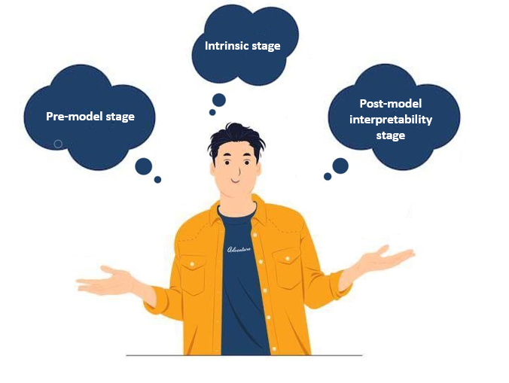
Interpretability, as the other part of the XAI theoretical framework, can be performed in three stages of the explainable ML modeling process. This feature could be observed in the form of three types or stages (Aslam et al,2022).

- Pre-model stage.
This type of interpretability has nothing to do with the model and is achieved before the implementation of the model and is solely based on data function, generally through data visualization and exploratory data mining such as exploratory factor analysis (EFA). This data interpretability is implemented prior to the formulation and implementation of the explainable ML model and plays a crucial role in determining the model. This type of interpretability is related to feature engineering. Psychologists are familiar with some of these methods in the form of descriptive statistics.
2) Intrinsic stage
This interpretability refers to self-explanatory models that reinforce natural interpretability with their internal structure. Intrinsic models include basic models such as decision trees, generalized linear models, logistic models, and clustering models. It should be noted that natural interpretability is associated with cost, depending on the model's accuracy.
3) Post-model interpretability stage
This kind of interpretability can be used for all black box models without the need to understand the internal structure. This interpretability can even be used for intrinsic models.
Data
Pre-model
Data
Model

Data
Intrinsic
Data
Explainable Model

Data
Post-hoc
Data
Model
XAI

Figure 2.9. Interpretability and models
In short, Figure 2.10 depicts the relationship among artificial intelligence, machine learning, and explainable artificial intelligence

Machine learning
Deep learning
Explainable AI
Artificial intelligence

Figure 2.10 Relationship among artificial intelligence, machine learning, and explainable artificial intelligence
Let us return to the ML classification, which is at the core of artificial psychology. Machine learning systems are generally divided into three categories, which can be briefly defined as follows. The basis of this division is the training type.
- Supervised learning:
In this type of machine learning, the system uses data for active learning to map inputs to outputs. The reason this type of learning is called supervised is that there is a solution. The solution is called the target variable, and in psychological research, it is called the criterion (dependent) variable. This variable has a specific label in the data (for example, one hundred boys with ADHD and one hundred non-ADHD boys) and there are some features as predictors based on which predictions are made; for instance, the child’s age, birth rate, and daily caffeine intake. In this example, since the target variable has a separate label and is already known, supervised algorithms such as linear regression, random trees, boosted trees, and neural networks (ANNS) are used in data training. This type of learning is the most widely used type of ML in the psychological sciences (Dehghan, Alashwal & Moustafa,2022; Vélez,2021).
Farahani et al. (2011) used a supervised learning algorithm in their study. Moreover, Roshan, Mohammadipour, and Farahani (2022) utilized multilayer perceptron ANNS machine learning to predict suicide attempts in a sample of 1132 Iranian male and female students based on 30 characteristics (emotional, cognitive, and orientation). The target variable was “with suicide attempt” “versus “without suicide attempt”.

- Unsupervised learning
Training data is not labeled in this type of learning. In other words, the solution does not already exist, and the system learns to find the hidden pattern in the data (such as the PCA, K-means, and auto-encoder clustering algorithm). The target variable (criterion) is not determined in this algorithm. This part of machine learning is more about general artificial intelligence. An instance of this can be found in the brilliant study by Grazioli et al. (2021) to personalize treatment in children with ADHD using the clustering algorithm.
- Reinforced learning
This algorithm differs from the previous two algorithms and their intersection (Figure11.2). In this algorithm, there is no machine training on the available data. There is an agent here performing actions in an environment and receiving a reward for each action, and its goal is to find a policy and strategy to maximize the reward.
Supervised
Unsupervised
Reinforcement

Figure 11.2 Supervised and unsupervised algorithms intersection
Deep learning algorithms should be considered here, which do not fit into these three divisions. Deep learning is a type of machine learning that runs with several hidden layers and yields the most successful findings and operations.
As described, there are three types of learning algorithms in the ML and deep learning systems, and there is no single solution or set of rules to tell which category needs more explainability than the rest. Explainability is associated with the interpretability of the algorithms in that category. According to Figure 11.2, there is a transversal and emerging necessity across the various domains of AI. In other words, although data-driven prediction and modeling are essential as a new field of artificial intelligence, it should be remembered that the principal basis of predictions in machine learning is correlation (Zhou, Bau, & Torralba, 2018). Furthermore, knowledge is generated when these predictions, classifications, and clusters are interpreted.

XAI
Prediction and Classification
Knowledge discovery and generation
Machine Learning
An Artificial Psychologist

Figure 12.2 Comparison of the purpose of machine learning and explainable artificial intelligence (XAI)
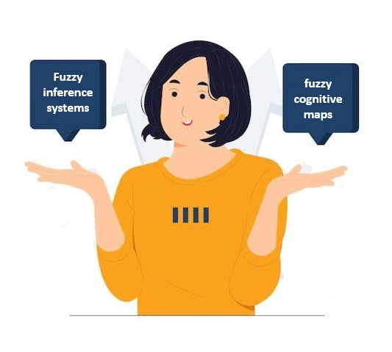
In summary, artificial psychology aims to apply explainable and interpretable artificial intelligence or, more precisely, explainable and interpretable machine learning to discover knowledge. The purpose of this new field of research is to study theoretical models using models based on explainable and interpretable artificial intelligence to be able to understand internal operations from a human point of view. This human-readable model combines accuracy with transparency and fidelity, which improves the models' weaknesses based on ML or AI. As a result, artificial psychology will be most helpful whenever models' ambiguity is reduced through using XAI, rule-based systems, and Bayesian models.
It is important to note that to reduce ambiguity using rule-based systems as well as the use of language variables that are most utilized in measuring structures, fuzzy inference systems (FIS) can be applied.
Furthermore, Bayesian Network Analysis (BNA) is an explainable and interpretable model based on prior knowledge and information. This prior knowledge helps to increase the transparency and fidelity and, thus, the explainability and interpretability of the model. This is one of the goals of artificial psychology. Figure 13.2 illustrates the artificial psychology subfields.

Figure 13.2 The XML structure

2.3. Artificial Psychology in Action
In addition to the theoretical knowledge, to become more familiar with the subfields of artificial psychology in this book, it is necessary to have the essential codes to run each algorithm of XML algorithms, fuzzy inference system, fuzzy cognitive map, and Bayesian network analysis using the R software, Python, and occasionally MATLAB. We know this book is not a software guide, but its purpose is to introduce the new field of artificial psychology and its sub-fields with examples.


R Software
For more than three decades, R (www.r-project.org) and Python (www.python.org) have facilitated the use of ML algorithms for everyone, as they are free and open-source. Recently, Julia (www.julialang.org) has emerged as a powerful, and effective alternative. Since 1995, R has been a language and environment with various statistical and graphical methods for classical statistics, machine learning, clustering, and predictive models and is highly expandable (R Core Team, 2021).
There are several freely available ML, FIS, FCM, and BNA packages in R. See the Comprehensive R Archive Network (CRAN) for more information.

Python Software
Guida Van Rossum developed Python software in 1991. It is widely-used software with a high-level, object-oriented programming language (Python Software Foundation, 2021). There are various Python packages for ML, FIS, FCM, and BNA.
The practice is further explained in the following. We do not look for coconuts on Coconut Island! The aim is to give a novel perspective, a novel function, and novel findings in psychological research.
Main Approaches for modeling a phenomenon
First, artificial psychology researchers must design their model to predict or classify the target variable. In this step, the researcher attempts to implement the desired model by examining the theory and research background. What are the predictors? Why are they chosen? What are the measuring tools? What is work innovation? This approach is called the knowledge-based or model-based approach in this book. In fact, in this approach, the initial, hypothetical model is designed through multiple sources including literature review, experience in the field and interviewing the target and the expert group, using qualitative analysis (thematic analysis and content analysis).
Model-based approach
Critical literature review
Qualitative research
Experience in the field
Designing model
Supervised algorithm
Semi-supervised

Rule-based models
Classification model
Prediction model
BNA FIS FCM ANFIS

Figure 14.2 The implementation process of a knowledge-based approach
The second approach, also called the data-driven or science-based approach uses data as the model’s source of inspiration. The present age has been called the age of data. Although big data has always existed, what is seen now is recorded big data, and there are various ways to record big data. In psychology, data can be obtained from multiple sources, from surveys and clinical batteries that measure essential dimensions of human behavior using EEG, reaction times, and genetic and omics data (Velez, 2021). Data recording through the Internet, national networks, and smartphones has led to a data explosion that may cause confusion. In this situation, the artificial psychologist attempts to reach an explainable and interpretable model based on data-driven models. We know that an artificial psychologist can collect data for a specific purpose and use the collected data to design the final model, an interpretable and explainable model. The following figure shows the data-driven model process in detail.
Network analysis
Data-driven approach
Pre-existing data
Obtained data
Unsupervised algorithms
Clustering
Rule mining
Model

Figure 15.2 Data-driven model process
It is necessary to know that the explainability and interpretability of model-based and data-based approaches are particularly important. It should be noted that explainability and interpretability are slightly more straightforward in supervised models because they occur in a label-bound environment. Moreover, the explainability and interpretability of white-box algorithms such as linear regression, decision tree, and logistic regression are not essential as their algorithm is quite clear.
In the following, explainability and interpretability in the knowledge-based and data-driven models in artificial psychology are explained in detail.

2.4. Interpretability and Explainability in a Knowledge-based Approach
As shown in Figure 15.2, this explainable artificial psychology approach, which is the book’s promised land, is of great importance.
In this approach, models are designed based on prior knowledge, and in quantitative studies, modern methods based on explainable machine learning, which is part of explainable artificial intelligence, are used. It should be noted that in this approach, rule-based models, including Bayesian Network Analysis, Fuzzy Inference System (FIS), Fuzzy Cognitive Map (FCM), and Adaptive Neuro-Fuzzy Inference System (ANFIS)) are all based on rules obtained through theoretical foundations, literature review, and experts’ opinions or raw data. Prior knowledge is their basis. Therefore, they are considered white boxes and are explainable and interpretable. However, we wish to call fuzzy logic models and fuzzy sets Grey Box because fuzzy logic sees Grey land as its promised land! Hence, the resulting model is explainable (internal explainability). Supervised and black-box algorithms need to be explainable and interpretable. Model explainability is a significant criterion for performing computational methods.
Target Group
Knowledge
Theoretical model
Supervised algorithms
Data gathering
Prediction
Classification
X post hoc
Black box

Figure 16.2 An illustration of explainability and interpretability route in models resulting from a knowledge-based approach

Various methods have been proposed to explain the models resulting from black-box machine learning. According to Jaganathan, Rehman, Tayara, & Chong (2022) these methods are of two types: model-explainability-based and instance-explainability-based approaches. Model-based and instance-based explainability in relevant texts are known, respectively, as global and local explanations. On the other hand, these explanatory approaches can be model-specific or model-independent (agnostic). Unlike model-specific explanation, the agnostic explanation can be used for any ML model, and typically this explanatory model is used post model or post hoc.
The Shapley Additive Explanations (SHAP) algorithm can be used for a general explanation in any ML model.
Supervised black-box algorithms
Model Explainibility
Post hoc
SHAP values
Global
Local
SHAP force plot
SHAP summary



Figure 17.2 SHAP algorithm for explainability and interpretability
Now it is time to deal with explainable and interpretable methods in models based on the second approach of artificial psychology, i.e., the data-driven. Unsupervised black-box models are challenging in terms of interpretation as most explainable methods in the XAI and XML require labeled data (Crabbe, & Schaar,2022). In other words, given the supervised algorithms for interpretability and explainability of algorithms in the second approach, several ways can be suggested based on the summary of one of the related sources. The model can be extracted from data based on unsupervised algorithms with a data-driven approach. Then white box algorithms (e.g., logistic regression or decision tree) or other supervised black-box algorithms or experts’ opinions can be used to explain it on the basis of the target variable. The explainability of the result can then be given by, for instance, running Random forest and/or Support Vector Machine (SVM) and SHAP or feature selection. Figure 17.2 represents this process.
Data-driven approach
Explainibility
Unsupervised black-box algorithms
Model
Experts’ opinion
White-box algorithm
Black box
SHAP
Summary
Force Plot

Figure 17.2 Representation of SHAP process
To sum up, in artificial psychology, test models are extracted and then explained and interpreted using two categories of supervised and unsupervised algorithms (semi-supervised and reinforced algorithms are not discussed in this book). Predictability and explainability with accuracy, precision, and human readability are the prime goals of this research field in psychology.

2.5. Achilles’ heel in Psychology

In recent years, several scholars have claimed that the theoretical foundation of psychology is shaky (Fielder et al., 2017; Eronen, &Bringmann2021). They believe that psychological theories in general are of low quality. Therefore, instead of focusing on improving statistical methods, researchers should focus on developing better theories. In other words, the theory crisis is the Achilles heel of psychology, and the theory crisis is more significant than the replication crisis. The critique of the state of theory development in psychology was first put forward by Paul Meehl (1960, 1967, 1978). He argued that although psychologists are interested in developing new theories, these theories are not presented in a consistent manner. They are not tested, proven, or disproven. They simply "exist" until they are forgotten or set aside.
Some believe that this type of theorizing and degradation of theories has led to the crisis of reproducibility.
Theories are undoubtedly the most powerful scientific tools available to psychological researchers, whether they are grand theories like Freud's (revolutionary views about humans) or small theory-rich bubbles. It can be argued that theories are typically developed by a small group of theorists. This problem is referred to by Mischel (2008) as the "toothbrush problem," i.e., psychologists view theories as toothbrushes: no one (typically) uses someone else's toothbrush. It should be mentioned that this does not mean that psychology lacks necessary theories. It means that psychological sciences lack theorizing and methodologies.
Researchers have mostly focused on developing hypotheses based on deduction and then testing these hypotheses by collecting data and using inductive (statistical) methods. In other words, the scientific method has been based on the mixture of deductive and inductive approaches.
Deduction refers to what must be there, while induction refers to what is operative. In other words, theories are the result of the process of hypothesis- deductive, which relies on the assumption that science develops via constant scientific testing. This is the underlying assumption of most of the books in psychology. Using deduction, induction and statistics is quite valuable and no one would undermine its importance and role, however, this approach is limiting and mechanical and the process of theorization is more than procedural steps.
The aim of this volume is to practically implement a method which by using big data, scholars’ views and interpretable and explainable artificial intelligence encourages psychologists to develop theories. Hopefully, the proposed methods in the book will be taken as the input of the abductive approach to generate theories.

Paradigm1
Emperical

Paradigm2
Theoretical

Paradigm3
Computational

Paradigm4
XAP

Robust Patterns

Theory Construction
Abduction
Computational

Figure 18.2 Paradigm view on the XAP
Perhaps this could be called the fourth paradigm in the history of psychological science(Figure 18.2).
Abduction can be seen as a transition from implausible explainability to plausible explainability, and thus plausibility is the main criterion. In deduction and induction, validity and uncertain reality are considered as the main criteria respectively. Therefore, in AP, robust patterns on the web are extracted using XAF and these patterns are then used in the process of theory building using the abductive approach. For example: a psychologist assumes that all symptoms of depression are detectable in children with autism. Then, among 20 autistic children attending a particular educational center, there is one child who does not appear to be depressed and is happy. Assuming that our 20-child sample is a valid sample, we can inductively say that not all autistic children are depressed and deductively we can say that all autistic children are depressed. The autistic child who is happy is an anomaly in the population, which may lead to some questions regarding the abductive approach: Is the child really autistic? Does s/he have a different type of autism? Can s/he be classified in another part of the spectrum? Does the child suffer from another disorder?
Let us take another example. Suppose one wants to predict suicide attempts using a multilayer perceptron neural network (or even Deep Learning), through employing features such as emotional schemas, cognitive schemas, and ontological schemas. After data collection and model preparation, the output would represent the importance of each of these features in classification. By, then, using the necessary patterns, such as SHAP and LIME, these features become interpretable and causative. The derived patterns can be used as input for theorizing, using an abductive approach.
XAP
Results

Theory

Figure 19.2 Theory building based on XAP
Is Big Data a new limitation in AP? How is it possible to use small samples and wish for development in AP?
Internet, digitalization and the ability to store data on different digital platforms have made Big Data more accessible. Big Data has always existed, but what we did not have was the record of Big Data that makes the fourth paradigm, data exploration, a reality. In psychological research, paper-based questionnaires have changed into hyperlinks that can be easily distributed among participants and accessed online via smart devices. As technology rapidly evolves, it seems that Big Data is becoming much more accessible. On the other hand, some might say that studies with a small sample size are not appropriate for theory development because these studies may not be transparent and their results may not be replicable (Aguinis, & Solarin,2019, Pratt, Lepisto., &Dane, 2019)
So, can we trust the conclusions? It should be said that, in practice, it is possible to find robust patterns in AP using relatively small samples. As explained by Purnam, Fang He and Shreshtha van Krogh (2021), machine learning is possible with this type of sample. Unlike classical statistical approaches (or inductive approaches) that rely on hypothesis testing, the main concern with machine learning is overfitting, which can be easily overcome with the methods presented in this book. A review of the literature in machine learning, the core of this volume, shows that more than 100 academic papers have been written using ”iris data”. This collection of data contains 150 observation cases involving 5 features (Dua, D. ,& Graff, C. (2017). We know that in some areas of psychological sciences, data are quite expensive. However, there are studies that focus on these problems and difficulties and try to solve the problems of studies with small samples.

