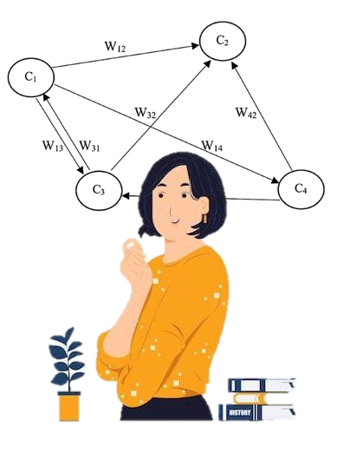

Chapter 4:

Fuzzy Cognitive Maps

CHAPTER 4 Contents:

4.1. Fuzzy Modeling of Human Knowledge: Towards Fuzzy Cognitive Maps in Psychology
4.2. Modeling based on psychological knowledge
4.3. Optimization in FCMs
4.4. Scenario analysis in FCMs
4.5. An Example for Artificial Psychologists

Abstract: The importance of shared personal experience and how this is quantified is shown. In particular the Delphi method introduced in the 1960s leads to the gathering of qualitative information from surveys or checklists which can be used in a Fuzzy Cognitive Map (FCM). FCM is a mathematical tool to model experiences expressed through language by people and take into account that personal terms such as “ strongly affect” are subjective to that person. A FCM is a directed graph with nodes (variables or concepts) linked by edges (signifying that the degree of relationship between a pair of nodes is above a threshold as to be of interest). The degree of relationship can be shown by the thickness, or weight, of an edge. A key aspect is the quantification of linguistic terms and to do this fuzzy membership functions are used which often take simple shapes such as triangular, trapezoidal or Gaussian. FCMs can be integrated to form a single pooled FCM which forms the input for analysis with the outcome a directed network of edges and nodes. An example showing the relationships between smart phone addiction, loneliness and cyber loafing using functions in R closes the chapter.
Keywords: Fuzzy cognitive maps; Delphi method; Language; Fuzzy membership; Defuzzification; Optimisation; DOCs

4.1. Fuzzy Modeling of Human Knowledge: Towards Fuzzy Cognitive Maps in Psychology

Psychology is the study of humans and, in a deeper sense, the study of mind and mental processes filled with many ideas to achieve goals and desires. Individuals gain valuable experiences in various situations that contribute greatly to the identification of relevant determinants. Those who have failed in relationships, individuals who have participated in weight loss classes, mothers of autistic children, the LGBTQ community, and those who have lived with MS for years are familiar with the basic mechanisms of such experiences. Quantitative studies often focus on factors or predictors or on the statistical inference of relationships between variables (Giabbanelli, 2014); rarely are individuals asked to estimate the effects of variables. For example, studies attempt to identify factors that affect the potential for addiction and measure the significance of such effects using inferential statistics, such as regression. However, these effects are not quantified. Perhaps a psychologist who is a proponent of Sigmund Freud believes it is inappropriate to ask individuals to estimate the effect of variables. They believe that individuals could not make accurate estimates because people are strongly influenced by the unconscious. Other theories, however, take the opposite view. Research has shown that individuals can accurately estimate how variables affect each other based on an internal schema of a complex system (Hayes, & Andrews,2020).
In order to gain knowledge of the human experience, people are asked to share their knowledge; they are asked to share their experiences rather than focusing on a single experience.

It can be said that individuals, consciously or unconsciously, reduce complexity when they are asked to create models of their experiences; this process can be done to avoid information overload and thus reduce mental effort (Vennix, 1996). Several studies have shown that this simplification is independent of expertise (Axelord, 1976), and solutions have been developed to address this challenge (Papageorgiou et al.,2020, Apostolopoulos et al ,2021 ).
Psychologists tend to come up with simple solutions! The simplest solution is to collect a data set rather than a person's experience. Research has shown that data sets are also prone to bias and would not necessarily lead to more accurate results (Vennix, 1996).
The Delphi method was introduced in the 1960s to collect group responses. Although it has resulted in accurate responses to a large extent, three major challenges still need to be addressed:
(1) Conflicts among participants due to the use of majority rule affect the Delphi method.
(2) Relationships have different weights, and the process focuses on the most influential relationships in a system; however, expressing causal relationships (e.g., very high or high) in linguistic terms contains vagueness. Linguistic terms are not unambiguous! This is an inherent property of words.
(3) Human knowledge is subject to uncertainty. Uncertainty is the price of living in this world. There is no free lunch!! Everything has its price, and uncertainty is the price we pay for the understanding of the real world; a not quite unaffordable price!
Thus, individuals' answers contain uncertainty and they try to express relationships based on their knowledge to a reliable extent. Fuzzy Cognitive Maps (FCMs) provide a technique to deal with such challenges. An FCM is a mathematical model that targets such problems, using fuzzy set theory to gather participants' experiences. FCMs were developed to represent uncertainty and vagueness mathematically to provide formulated tools for dealing with impressionism in real-world problems (Li, J, et al, C.2006). An FCM includes linguistic terms and helps participants share their experiences. For example, participants may say, "My relationship with my mother strongly influences my mentalized affectivity." The term "strongly affect" has different meanings for different people. It is defined by fuzzy set theory based on overlapping membership functions.
Linguistic terms are integrated into an FCM by rules. For example, if 35 out of 50 alpha women say "my relationship with my mother has a very strong influence on my mentalized affectivity," and the remaining fifteen say "my relationship with my mother has a strong influence on my mentalized affectivity," the confidence factors of the linguistic terms "very strong" and "strong" are calculated as 0.7 and 0.3, respectively. This is discussed as a fuzzy implication rule in the development of FCMs. The confidence factor represents uncertainty and plays a key role in quantifying participants' general experiences.
To model relationships between variables, several approaches have been introduced. Structural equation modeling (SEM) cannot use linguistic variables and scenario and feedback analyzes. The system dynamics approach requires a mediator to resolve vagueness, uncertainty, and conflict among participants. Bayesian networks allow inference under uncertainty, but classically fail in the study of feedback. These shortcomings need to be addressed in FCMs.

4.2. Modeling based on psychological knowledge

Where does the psychological knowledge of researchers in the psychology literature, which is the modeling engine of artificial intelligence (AI) psychologists, come from?

The knowledge needed in psychological literature is obtained through qualitative and quantitative methods. Psychological researchers attempt to explore the mindset of the target group using qualitative schemas, often using content analysis, thematic analysis, grounded theory, and phenomenology (phenomenography) in the form of non-directive in-depth interviews. For example, a target group may include experts, patients, mothers, and couples who can provide the knowledge needed to construct the model.
A researcher is like a bee sitting purposefully on a flower, feeding on nectar and producing honey. Researchers seek in-depth, qualitative assessments of phenomena that are not precise, but rich in concepts. They search for the gold of facts in the minds of informants. After interviewing the target group, the interviews are coded using transcription to extract themes and categories. Once the extraction of themes and categories is complete and the trustworthiness of the results is assessed, an FCM can be developed based on the resulting conceptual model using the principles of qualitative methodology.
In addition, a significant amount of psychological knowledge is obtained through quantitative methods based on questionnaires, scales, standard tests, observation checklists, smart devices, and archived patient records. In such methods, concepts and variables can be extracted by reviewing the literature before implementing a statistical model. The resulting coefficients can then be used to create weighted matrices for an FCM. Therefore, two FCM models can be developed: (1) the thematic tree-based FCM (TTBFCM) and (2) the SEM -based FCM (SEMBFCM).
TTBFCMs can be referred to as qualitative or expert-based models (thematic tree-based models in a more general sense). Themes are extracted from non-directive in-depth interviews with the target group and coded using qualitative methods. However, psychologists are aware that a qualitative schema must be aligned with psychology to extract themes.
Once theme extraction and the evaluation of the trustworthiness of the themes are completed, a tree of themes is created. This is discussed below as the basis of the primary FCM models.

Draft model
Thematic tree
Finalization of the concepts
FCM initial model
Effect determination as linguistic terms
Experts’ panel or target group or both
Theme extraction
Quality analysis
Phenomenon determination
Target group determination
Interview
Transcription

- The procedure of constructing TTBFCM

The thematic tree is created in draft form and presented to the expert panel (at least ten experts) to be finalized based on the concepts (nodes) or themes, their causal relationships, feedbacks, and loops. The experts are also asked to express their opinion on the causal relationships linguistically (e.g., very high or high). The arrows of the model are labeled. Figure 4.1 illustrates the thematic tree created to assess adjustment after self-injury in female adolescents as the primary model of an FCM
Domain experts sometimes have different views on model concepts. In such a case, each causal matrix must be completed by adding new columns and rows with zeros for additional concepts. In this way, all causal matrices have the same dimension, and the integration of FCMs can yield a comprehensive description of a single FCM. For example, experts 1 and 2 propose FCM1 and FCM2 for working memory. Then, an integrated FCM can be obtained.
C₁
C₂
C₃
C₄
0.5
-0.31
-0.7
C₁
C₂
C₄
0.6

-0.7
C₁
C₂
C₃
0.40
-0.31
FCM₂
FCM₁

- An integrated FCM using 2 experts’ FCMs
The necessity of FCMs could be determined, as shown in Table 1.
Group Name | Essential | Not essential but useful | Non-essential | Comments

Then, the CVR was calculated as:
$$CVR= \left(N_{e}-N/2\right)/\left(N/2\right)$$
(4.1)

Where Ne is the number of experts who consider the node necessary, while N is the total number of experts (10 in this case). The CVR of each node was compared with the Lawshe table, and the nodes whose CVRs were above the Lawshe table remained in the model (Ayre &, Scally, 2013).
SEMbFCMs are also a technique for extracting knowledge from questionnaires, scales, tests, smart tools, and observational checklists or brain data, e.g., electroencephalography (EEG). A model can be developed by reviewing the literature, expertise in the field, and expert opinion on SEMbFCMs. Quantitative techniques are used to quantitatively measure the model on a larger scale; the model can then be fitted using SEM. Partial Least Squares (PLS) will be used for small samples (Hair, Hult, Ringle, & Sarstedt,2022). The standardized path coefficients are assumed to be the weights of the FCM matrix.
However, statistical feedback does not exist in SEM and can be obtained from expert perspective (the structural and relational modification of the model). Figure 4.3 shows the procedure for designing a SEMbFCM model. The FCMs are explained in more detail below.

Extraction of standardized path coefficients
FCM draft model
Model structural and relational modification
Providing model variables’ measurement tools
Implementing in a proper sample
Running the model
Literature review
Expert’s experience in the field
SEM model design

- The procedure for designing a SEMbFCM model

Axelord (1976) proposed cognitive mapping theory (CMT) to model social science knowledge. Kosko (1986) then introduced FCMs as an extension of CMT to model and analyze complex systems. FCMs can be considered as a knowledge-based methodology that simulates dynamic systems. It integrates fuzzy logic, neural networks (which will be explained in the next chapters), and cognitive maps to represent knowledge about systems whose characteristics are uncertainty, causality, and complex processes.
The FCM is structurally a fuzzy directed graph with feedbacks consisting of components known as nodes and causal relationships between components (nodes) known as weighted directed edges. The dynamics of such systems are tested by simulating their behavior in discrete simulation steps. In general, FCMs can be designed based on inputs from domain experts, system data, or a mixture of experts and data (i.e., expert-based, data-driven, and hybrid FCMs).
The node concept is determined based on the activation degree. A degree of activation refers to the degree to which the corresponding concept (node) influences other nodes in the FCM. Relationships between concepts are defined as positive, negative, or zero. Here, W_{ij} represents the relationship between concepts (nodes) C_{i} and C_{j}. It can be positive, zero, or negative. Its sign (whether positive or negative) represents the direction of the effect, while its absolute value represents the intensity of the relationship.
Recently, especially in the last 30 years, FCMs have been of great interest to researchers in a variety of fields. They have unique advantages over classical models, including the ability to clearly represent relationships between concepts (nodes) and the study of latent patterns (relationships) between nodes. In addition, their causal semantics can be predicted to analyze, simulate, and test the effects of parameters and estimate the behavior of the system.
C₃
C₁
C₄
C₂

- A simple FCM including edges and nodes
As mentioned earlier, there are three approaches in FCM design, namely expert-based, data-driven, and hybrid approaches. However, since explainability and interpretability are at the core of AI psychology (the title of this book), the expert-based approach is said to be the dominant FCM design approach.
The model was designed based on the expert opinions and then delivered to the experts with causal relationships to determine the relationships using linguistic terms (e.g., very strong, strong, moderate, weak, very weak). Then, the linguistic terms or ratings were converted into numerical weights using fuzzy logic (Mkhitaryan et al., 2021). These steps are simple and can be performed by AI psychologists.
Linguistic evaluations are converted into numerical weights in four steps:
Step 1: Defining fuzzy membership functions
Fuzzy membership functions or numbers (e.g., triangular, trapezoidal, and Gaussian) are used to transfer linguistic terms into a specific numerical interval or universe of discourse. The universe of discourse is defined in FCMS in the range (-1, 1) when negative causality is possible; otherwise, the range is (0, Y).
To define a membership function, its form must be determined. As mentioned earlier, there are a variety of membership functions; however, triangular membership functions are the most commonly used. A triangular membership function has an upper bound, a midpoint, and a lower bound (Figure 4.5).
Lower bound
Center
Upper bound

- A triangular membership function
Step 2: Applying the fuzzy implication rule
In order to determine the degree of activation of the linguistic variables representing the relationships between certain nodes, it is necessary to determine the extent to which the linguistic terms have been verified by the participants. The degree of causal effect of an antecedent on a consequent in terms of linguistic terms is determined. Then, the fuzzy implication rule is applied to activate the membership functions. In this context, Larsen's product and Mamdani's minimum are often used. Based on Mamdani's rule, the membership function is truncated at the verification level (Eq. (1) and Fig. 1). Based on Larsen's rule, the membership function is rescaled (Eq. (2) and Fig. 2).
Mamdani's Minimum:
$$H_{R}\left(x,y\right)=min\left[H_{A}\left(x\right),H_{B}\left(y\right)\right]$$
(4.2)
Larsen’s Product:
$$H_{R}\left(x,y\right)= H_{A}\left(x\right).H_{B}\left(y\right)$$
(4.3)
The next step after applying the percentage importance in the rule is aggregation.
Step 3: Integrating the fuzzy membership functions
The activated fuzzy membership functions are integrated. Several techniques have been proposed for integrating membership functions, including:
- Techniques for integrating membership functions
Argument | Option | Description | Equation
Method | ‘algsum’ | Family algebraic sum | $$x+y-xy$$
 | ‘esum’ | Family Einstein sum | $$\frac{(x+y)}{1+xxy}$$
 | ‘hsum’ | Family Hamacher sum | $$\frac{x+y-z*y}{(1-x*y)}$$

Where X and Y are the membership values of the linguistic terms activated in the previous step.
The last step of FCM is routinely defuzzification of the integrated membership functions.
Step 4: Defuzzification
A number of defuzzification methods have been introduced, including the Center of Gravity method. Defuzzification is used to convert the fuzzy FCM values into crisp numbers. Several defuzzification methods are available in Python, as shown in Table 3.

- defuzzification methods
Argument | Option | Description
Method | ‘Centroid’ | Centroid
 | ‘Bisector’ | Bisector
 | ‘mom’ | Mean of maximum
 | ‘som’ | Min of maximum
 | ‘lom’ | Max of maximum

Simulation is an important aspect of FCMs. The dynamics of an FCM are determined by simulating its behavior in discrete simulation steps. The concept values are updated in the simulation using inference methods. The FCM expert must use the following inference rules:
Kosko
Kosko's activation rule with self-memory (modified Kosko)
Rescaled activation rule
Where $A_{j}^{t}$ is the value of node j in step t, $W_{ij}$ is the causal effect of concept (node) j on concept i, and f(x) is a transfer function. The transfer function is used so that the values fall within a certain range - for example, (0, 1) and (-1, 1) for the sigmoid and hyperbolic tangent transfer functions, respectively. There are five transfer functions, including:
- Sigmoid X is defuzzified value λ is a steepness parameter for the sigmoid function
- Saturation function
- Bivalent
- Trivalent
- Hyperbolic
The simulation runs until one of two discontinuity criteria is met: (1) the concepts have a difference in two consecutive steps that is smaller than the threshold difference so that the network converges at a fixed point, or (2) the predefined maximum number of iterations has been completed.
$$∃\left(E1,2,…,t-1\right): \left|A^{t+1}-A\right|<threshold$$
(4.4)

In FCM inference and simulation, the FCM expert defines an initial state vector in which the values of the concepts are determined by the FCM expert. An FCM weighting matrix, i.e., a connection or adjacency matrix, is also required. Once the initial state vector and the FCM weight matrix are multiplied, the system is updated until one of the two termination criteria is met.

4.3. Optimization in FCMs

An expert-based FCM can converge to undesirable positions, which is a drawback. Therefore, such models predict only extreme values. Researchers have proposed a number of techniques to circumvent this drawback (Lavin et al., 2018).
The active Hebbian learning (AHL) and nonlinear Hebbian learning (NHL) approaches have been proposed. They are based on the Hebbian learning rule. Here, machine learning (ML) and the FCM approach are integrated. These algorithms aim to modify the initial weight matrix so that the selected nodes converge in the predefined region. These nodes are referred to as DOCs. Although human knowledge is a powerful tool in the design of FCMs, expert opinions may be lacking or too subjective and inaccurate in some cases (Papageorgiou, 2011). In addition, there may be too large a number of variables/components. Learning algorithms are a mechanism to address such challenges. These algorithms increase the accuracy of the weights and reduce the dependence of the weights on expert opinions, improving the performance of FCM by creating a learned weight matrix (Papakostas et al., 2011; Papageorgiou, 2011). Overall, learning algorithms cope with the convergence problem of FCMs and enable reliable decisions (Papageorgiou et al., 2004).
Learning algorithms are similar to simulations. However, learning algorithms update the values of the concepts (nodes) at each time step, whereas simulations only change the concepts (nodes) (Papageorgiou et al, 2004). AHL updates the nodes and weights asynchronously based on the activated pattern sequence. It not only optimizes the existing wedges, but also creates new weights between nodes that may not be desirable.
Based on such optimization algorithms, the learning process continues until one of two termination criteria is met: (1) the fitness function F1 of each DOC decreases at each time step, or (2) the DOCs fall within the predefined range.
The fitness functions of the DOCs are calculated (Eq. (4.5)). For the second criterion, it is important to identify whether the DOC is fixed (F2). A threshold is defined, which should be (0.001, 0.005). As soon as it is reached, the process is terminated. The learning process is terminated as soon as the two termination criteria are met. Otherwise, the predefined number of iterations is performed.
$$F_{1}=\sqrt{{\left|{DOC}_{j}^{k}-\frac{{DOC}_{j}^{min}-{DOC}_{j}^{max}}{2}\right|}^{2}}$$
(4.5)
$$F_{2}=\left|{DOC}_{j}^{k+1}-{DOC}_{j}^{k}\right|<e$$
(4.6)
To implement the AHL and NHL algorithms, the initial weight matrix, initial concept values, and DOCs must be determined. In addition, the learning rate, the decay coefficient, and the coefficient of the sigmoid function should be determined as hyperparameters. The slope and decay rate of NHL and AHD as well as the learning rate are usually set to [0.9, 1001], (0.99, 1), (0.01, 0.1), and (0.00, 0.1), respectively. It should be noted that population-based search methods exist for learning in FCMs used to optimize weights and slopes. (Mkhitaryan, Giabbanelli, Wozniak, Nápoles, De Vries, &Crutzen ,2022).

4.4. Scenario analysis in FCMs

The analysis of scenarios and their effects on the model is an advantage of FCMs. A scenario can be assumed to be a new FCM factor whose causal effect on the target concepts (nodes) is measured (continuous interventions) or that changes the base values of the concepts (nodes) to the values of the target concept (nodes) values (one-time interventions).
To evaluate continuous interventions in Python, the name of the intervention, the concepts (nodes), the targets, and the effects of the nodes on each other must be determined. For one-time short interventions, on the other hand, the name of the intervention and new initial states must be determined. It is also proposed to evaluate the effectiveness of a given intervention in the range of (0, 1), where 1 is the maximum effectiveness. The strength (intensity) of the intervention is intended, and the actual value of the change (increase or decrease) after the intervention is simply determined (Mkhitaryan et al.,2022).
Actual effectiveness due to intervention = expected effectiveness * amount of effectiveness after intervention
To assess explainability, which is the main goal of explainable AI psychology, charts are used to measure the changes after each intervention

4.4.1. Practical example using R

An artificial psychologist tries to simulate a model based on FCM to explain cyber loafing. He derives an initial conceptual model based on an in-depth review of the related research background. In this model, he specifies 2 important variables C1 and C2 in relation to the target variable (Cyber loafing): (Smart phone addiction = C1) and (Loneliness = C2). He then consults with a research team who have worked in the field of Cyber Psychology. They also suggest the stress variable and the final model is conceptualized as follows, where C3, stress, and C4 are the target variable, i.e. Cyber Loafing.
C1
C2
C3
C4

- Hypothetical model Of FCM
The assumed model is presented to 2 experts who work in the field of mental health and health psychology, and they are asked to specify the label of each path (edge) in an 11-category scale.
Table 3, shows the fuzzy set, type of fuzzy membership, and the parameters, the direction (sign) and size (the degree of influence of each variable).

- The fuzzy set, type of fuzzy membership, and the parameters
Fuzzy set | The type of fuzzy membership functions | Parameter
very high negative (-VH) | triangular | (-1 , -0.75 , -0.5)
high negative (-H) | triangular | (-1 , -0.75 , -0.70)
negative average (-V) | triangular | (-0.75 , -0.5 , -0.25)
negative bottom (-L) | triangular | (-0.5 , -0.25 , 0)
very low negative (-VL) | triangular | (-0.25 , 0 ,0)
don't know (NA) | triangular | (-0.001 , 0 , 0.001)
very low positive (+VL) | triangular | (0 , 0.25 , 0.5)
positive low (+L) | triangular | (0.25 , 0.75 , 0.8)
Medium Positive (+M) | triangular | (0.5 , 0.75 , 1)
high positive (+H) | triangular | (0.57 , 1 , 1)
Very high positive (+VH) | triangular | (0.75,1,1)

Then the experts were asked to specify in the figure if they consider each of the fuzzy sets suitable for each edge in the assumed model. The figure shows the opinion of expert 1 about the routes.
+VH
+H
C3
C4
C2
C1
+H
+H
+VH
+H

- FCM model based on Experts' Opinion
Then, using the necessary codes in the software of these comments in the form of Fuzzy Logic, it is aggregated and the matrix of weights is formed, or adjacency matrix.
- The adjacency matrix of the FCM
C4 | C3 | C2 | C1
0.92 | 0.28 | 0.75 | 0 | C1
0.89 | 0.79 | 0 | 0 | C2
0.90 | 0 | 0 | 0 | C3
0 | 0 | 0 | 0 | C4

After 5 iterations and C3 = stress = 0.71 and target variable = cyber loafing = 0.84. The diagram is in the figure 4.7. In FCM, the initial value determined by the artificial psychologist for variables C1 and C2 is called the Initial Vector or Activation vector. This vector contains values related to concepts or primary nodes, each of which is activated by assigning the number 1 or a number between 0 and 1. The weight matrix or adjacency matrix actually shows the normalized relationships between concepts or variables, which are usually placed in the distance (0 and 1) or (-1 and +1). The number of iterations is the number of times after which the values obtained from the simulation do not change more than a certain limit (threshold). For fuzzy inference based on FCM, it is necessary to determine the rules. In general, Dikopoulou and Papageorgiou (2017) introduces 6 different rules for fuzzy inference, which are:
1) Kosko, "k", 2) modified Kosko, "mk", 3) Rescale, "r", 4) Kosko-clamped, "ks" 5) modified Kosko clamped, "mkc", 6) Rescale clamped, "rc". As a pre-selected default, the inference rule is usually set to Kosko. In this example, as specified in the R codes, the artificial psychologist used Kosko's rule for inference. Since the output of the vector product in the weights matrix may be a non-fuzzy number {out of 0 and 1 or -1 to +1} to convert that number to a number that is in the range of 0 to 1 or -1 to +1 The transformation function is used. These functions are Bivalent, "b", Trivalent, "tr"., Sigmoid, "s" or Hyperbolic tangent, "t", are and by default. From the function sigmoid, "s" is used. To stop the iteration, the value of epsilon (e) is used, which indicates the minimum difference between the concepts resulting from the iterations. By default, these values are 0.001. In this example, e=0.001 was considered (figure 4.8 and figure 4.9).
As explained in the previous section, since the weight matrix or adjacency matrix may falsely converge, the AHL and NHL approaches are used for this reason. The purpose of these two algorithms is to modify the initial weights matrix so that the nodes converge in the preferred area and do not reach an incorrect and premature convergence. It is possible to obtain adjusted matrices by using Python software and running AHL and NHL, and then import them into R for calculation.
Fuzzy sets and its parameters were approved by experts, see the R codes to draw the shape of this table and its output in listing 1.

- R codes for FCM
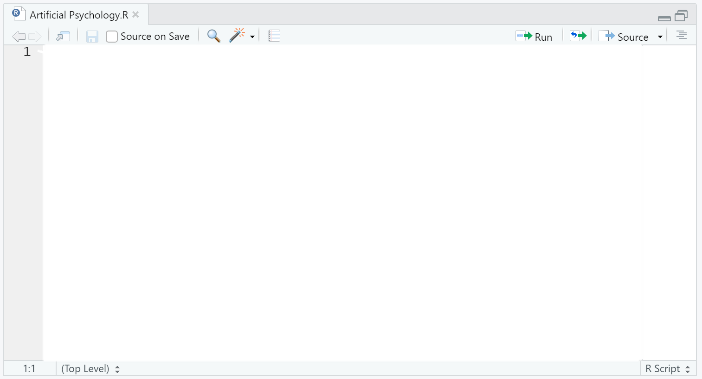

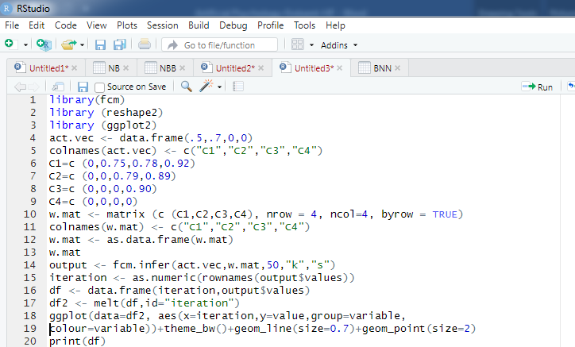

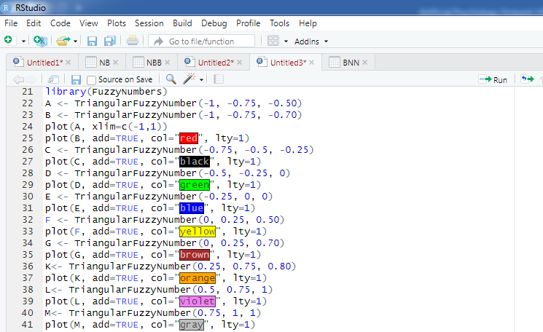
- (continued (R codes for FCM

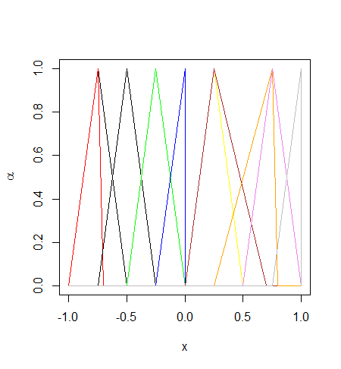

Figure 4.7 The fuzzy membership function showed in table 3
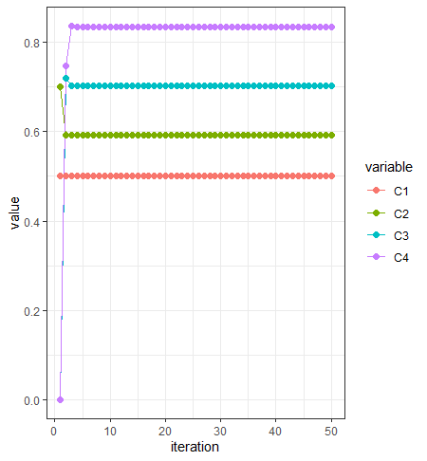

Figure 4.8 the plot of the iteration step
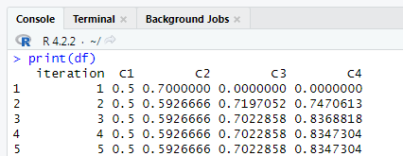
Figure 4.9 converging the FCM at iter5

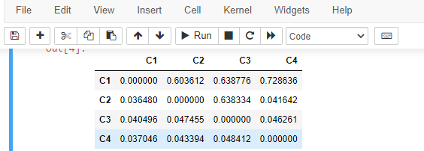
AHL

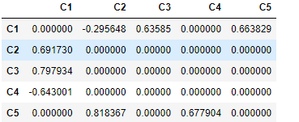
NHL

Figure 4.10 The output for AHL and NHL
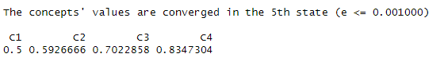
Figures 4.10 show the output of AHL and NHL. In Python software, there is a very good library for FCM implementation, which is out of the scope of this book. Based on that, more diverse and interesting findings can be achieved with this method.

Figure 4.11 The results of simulation of FCM
The final concept vector to be: C (5) = [0.50, 0.59, 0.71,0.84]. The final values of decision concepts are stress = 0.71 and cyber loafing = 0.84 of the decision-making problem (Figure 4.11).
Farahani, Nápoles, and Azadfallah(2021) using FCM for studying psychological well-being. In this paper you can find some computational detail.

