Installing and Using the Bootstrap Excel Add-in

Software for

Introductory Econometrics

by
Humberto Barreto and Frank M. Howland
barretoh@wabash.edu and howlandf@wabash.edu
(765) 361–6315 and (765) 361–6317

WARNING:
This software was written and designed for teaching purposes. It has been tested on several examples but not on a wide variety of data sets. For mission-critical projects, always check the results with full-fledged statistical programs.

The Bootstrap add-in is Bootstrap.xla (on the CD-ROM, it is in BasicTools\ExcelAdd-Ins\Bootstrap).

PURPOSE OF THIS DOCUMENT

This document describes how to install and use the Excel add-in Bootstrap.xla to run a bootstrap simulation of one or two cells in an Excel workbook.

INSTALLING AND LOADING

Microsoft offers the following description of an Excel add-in:

Add-ins are programs that add optional commands and features to Microsoft Excel. Before you can use an add-in, you must install it on your computer and then load it in Microsoft Excel. Add-ins (*.xla files) are installed by default in the Library folder in the Microsoft Excel folder. Loading an add-in makes the feature available in Microsoft Excel and adds any associated commands to the appropriate menus. [Microsoft Excel Help, add-ins, overview]

Thus, to install an add-in is to have an add-in file (*.xla) in the Library folder of your hard drive. To load it, you must complete an additional step using the Add-In Manager. Fortunately, you need to do this only once.

Step 1: Installing the Bootstrap.xla file

If you are accessing the Bootstrap.xla add-in from a CD-ROM, place the CD in your computer. If accessing from a network server, make sure you can read from the appropriate network drive.

If you do not have CD-ROM or network access to the Bootstrap.xla add-in, download it by visiting <www.wabash.edu/econometrics>. Download the Bootstrap.xla file directly to the appropriate add-ins folder on your hard drive (usually, C:/Program Files/MicrosoftOffice/Office/Library), or move it there after downloading to your hard drive.

Step 2: Loading The Bootstrap.xla add-in

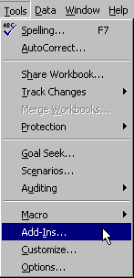
Once the Bootstrap.xla file is accessible, launch Excel and use the Add-In Manager to load the Bootstrap add-in. First, open the Add-In Manager by clicking on the Tools menu item and selecting Add-Ins.

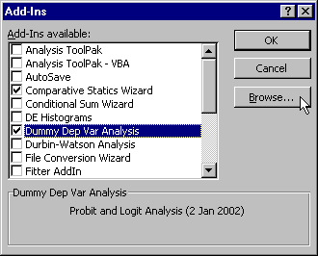

If the Bootstrap add-in is not listed in the Add-Ins scroll box (as in the example above), click the Browse (or Select) button, navigate to the Bootstrap.xla file on the CD-ROM or network drive, select it, and click OK.
Mac Note: Some versions of OfficeX report, “Unable to Copy add-in to the Add-ins folder.” This is a bug. The add-in really is there. Simply quit Excel, then restart it, return to the Add-In Manager, and continue following the instructions.

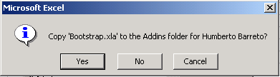

Click OK if you are asked to write the Bootstrap.xla file to the Addins (or Library) folder. The Add-In Manager dialog box will now list the Bootstrap add-in.

The Add-In Manager lists all of the installed add-ins, and those with checkmarks are also loaded. Microsoft offers the following advice, “To conserve memory, unload add-ins you do not use often. Unloading an add-in removes its features and commands from Microsoft Excel, but the add-in program remains on your computer so you can easily load it again.” [Microsoft Excel Help, add-ins, overview]

Make sure to select the check box next to the Bootstrap add-in and click OK.
Excel will load the Bootstrap.xla file and notify you of successful installation with the following message:

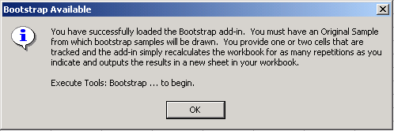

USING THE BOOTSTRAP.XLA ADD-IN:

Using the Bootstrap add-in is easy, but it requires a little planning. Suppose you have an Excel workbook with data, which we will call the original sample, and you have computed a sample statistic (e.g., the average or a regression coefficient). To use the bootstrap add-in, you have to create a place in the workbook where the samples taken from the original sample can be placed and the statistic of interest computed. There are two ways to do this.

First, if the original sample is small, simply copy the cells containing the original sample and statistic of interest; then paste these cells elsewhere on the same spreadsheet. This approach was used in the first two sections of the bootstrap chapter.

However, if the original sample is too large (e.g., more than 123 columns), then duplicating the entire sample and statistic on the same sheet may not be possible. In addition, if many different calculations are performed (especially if you have user-defined functions), copying and pasting cells on the same sheet will be much slower. In these cases, you can simply copy the entire sheet (execute Edit: Move or Copy sheet and check the Create a copy option). The original sheet contains the original sample, and the copied sheet will serve as the place where bootstrapped samples are repeatedly written. You do not want to run the bootstrap add-in on your original sample sheet because it will destroy your original sample. The add-in does have an error check that prompts you to make sure you really mean to overwrite cells with data.

Let us work on an example to see how the bootstrap add-in actually works. Open the Excel workbook BootstrapDemo.xls to practice using the Bootstrap add-in.

The Data sheet has the Original Sample data, and cells C1 and C2 contain two statistics, the average and median, which we want to bootstrap. Execute Edit: Move or Copy sheet and check the Create a copy option. Rename the Data (2) sheet, “Bootstrap Samples.” From this new sheet, you are ready to test drive the bootstrap add-in.

Execute Tools: Bootstrap . . . in order to get the Bootstrap dialog box:
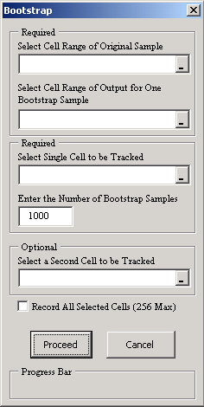
Click here to make the dialog box collapse so you can see the sheet.
Check this box to record all cells that have been selected before executing Tools: Bootstrap.

Click in the Select Cell Range of Original Sample box, then click on cell A1, hold down the Shift key, and click on cell A21. Repeat this procedure for the Select Cell Range of Output for One Bootstrap Sample input. For the Select Single Cell to be Tracked input, click on cell C1; and click on cell C2 for the Select a Second Cell to be Tracked option.

You are now ready to go. Click the Proceed button. The add-in warns that you are going to overwrite existing data:

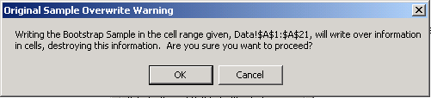

Because we have the original sample stored in the Data sheet, we can safely proceed in overwriting the data on the Bootstrap Samples sheet. If you are unsure of the answer to this question, it is always best to cancel and make sure your original sample will not be destroyed by the bootstrapping process.

Use the Progress Bar to gauge how long it will take to finish the simulation. You may use other programs while the simulation is running, but that may slow Excel down. You can always hit the Escape (ESC) key (on the top left corner of most keyboards) to kill the simulation. Click End when prompted. The add-in runs faster if no other Excel workbooks are open.

The bootstrap results spreadsheet in your workbook is alive—you can change the scale, title, and legends on the graphs, change labels and colors on the cells in the spreadsheets, and add descriptive information as needed. The data underlying the graph are available by scrolling right.

You can run as many bootstrap simulations as you want by simply returning to your original worksheet, copying the sheet, and executing Tools: Bootstrap. Delete unwanted results by simply deleting the unwanted sheet.

If you check the Record All Selected Cells option, the add-in will track all cells that were selected before you executed Tools: Bootstrap and brought up the Bootstrap dialog box. The add-in inserts a new worksheet in your workbook and shows all of the values generated by the bootstrap simulation. You can use this information to sort the results in order to find percentiles (e.g., for confidence interval estimation) and to track more than just one or two cells. To use this option, remember first to select the cells you want to record (using the CTRL key, as usual, to select noncontiguous cells); then execute Tools: Bootstrap and check the option.

The results generated by the Record All Selected Cells option are in “raw” form. You will need to compute averages, SDs, and draw histograms on your own. (Our Histogram add-in is a convenient tool for drawing one-variable and two-variable (superimposed) histograms.) You can see the full set of simulation results for any cell (including one that was chosen as a tracked cell) by simply selecting that cell before executing Tools: Bootstrap and then checking the Record All Selected Cells option. From the BootstrapDemo.xls workbook, select cells E1 and F2 and execute Tools: Bootstrap. The BootRaw sheet shows the output.

UNDERSTANDING THE BOOTSTRAP ADD-IN

The logic of the add-in is really quite simple. Excel stores the original data in an array and takes a random sample from that array of exactly the same size as the original sample. It then places the data on the worksheet and recalculates the worksheet, getting values for any statistics or formulas that are based on the pasted data. It stores the value of the tracking cell (or both tracking cells) after each calculation. The results are then presented in a new worksheet in your workbook.

Because Excel takes the original sample and stores it internally in an array, you cannot have any live cells (with formulas) in the original sample range of cells. The original sample is read once, and it does not change throughout the entire bootstrap procedure. Thus, when planning your bootstrap simulation, make sure that you do not use live cells in your original sample.

When sampling with replacement from a finite population, it is possible to obtain a sample in which the statistic may evaluate to an error value (e.g., in a regression context, perfect multicollinearity means the regression coefficients cannot be computed). In this case, the add-in will simply ignore that “bad sample” and draw another sample. At the end of the analysis, if any bad samples have been generated, the number is reported by a message box:

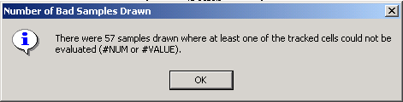

ERRORS and TROUBLESHOOTING

In addition to the “data overwrite” warning, the Bootstrap add-in has a few simple error checks.

It will complain if you attempt to do a bootstrap with a tracking cell that is not a formula:

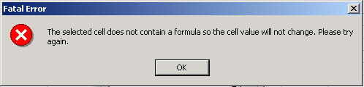

Clicking on the cell to be analyzed is better than typing it in because you might make a mistake entering the address. If you enter, for example, “=$A$,” for the Original Sample range, you will get

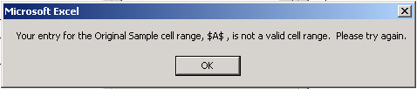

The add-in checks to make sure the cell you selected for analysis changes when the sheet is recalculated. For example, suppose you selected range A1:A21 for the Original Sample and chose to put the Bootstrapped Samples in cells B1:B21, tracking cell C1. Because cell C1 does not change (because the random samples are put in cells B1:B21 and cell C1’s formula is “=AVERAGE(A1:A21)”), the add-in reports a problem:

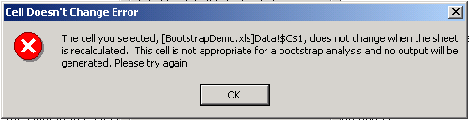

Finally, if you check the Record All Selected Cells option and have selected more than 256 cells to record or ask for more than 65,535 repetitions, there will not be enough room on the sheet. The maximum size of an Excel spreadsheet is 2^16, or 65,536, rows by 2^8, or 256, columns. Thus, the add-in will display a warning like this one:

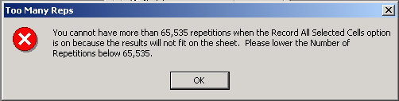

Also, if you are having trouble using this feature, remember to select the cells you want to record first (using the CTRL key to choose nonadjacent cells); then execute Tools: Bootstrap. The add-in automatically records any cell that is highlighted (i.e., selected) on the sheet.

THIS VERSION
The latest Bootstrap.xla version is 11 August 2005.

To check the date of your installed add-in, execute Tools: Add-ins and then highlight the add-in. The Add-Ins dialog box displays the date at the bottom.
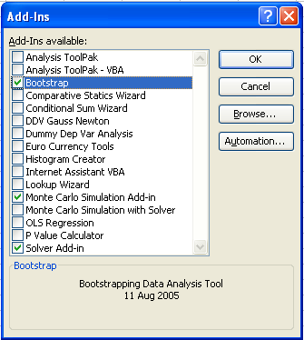
To install this for the first time, please follow the instructions on the first page of this document.

To install over a previous version that is already installed, please see InstallingAddinOverPreviousVersion.doc

To install over a previous version, quit Excel and simply drag this new version into the Excel Add-ins folder. If you do not know where this folder is, search for “bootstrap.xla” and then drag the new version over the old one. Of course, you will want to accept rewriting over the previous version.

ADDITIONAL HELP AND FEEDBACK:

If something goes wrong in the installation or loading process, an unexpected error keeps recurring, or you have other problems, please contact us. We are interested in your comments, suggestions, or criticisms of the Bootstrap.xla software.

www.wabash.edu/econometrics

Humberto Barreto  Wabash College  barretoh@wabash.edu  (765) 361–6315 | Frank Howland  Wabash College  howlandf@wabash.edu  (765) 361–6317

